Tyler Fultz, Jae Min Baek

Setting up ADS

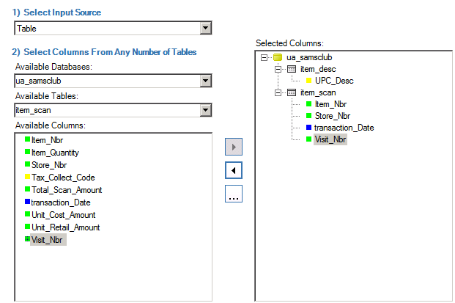

Where Clause:

(store_nbr = 22 OR store_nbr = 24 OR store_nbr = 26) AND (EXTRACT(month FROM transaction_date) = 1 AND EXTRACT(year FROM transaction_date) = 2000 )

Full SQL:

DROP VIEW "ES86619"."market_basket";

CREATE VIEW "ES86619"."market_basket" AS (

SELECT

"_twmads0"."UPC_Desc"

,"_twmads1"."Item_Nbr"

,"_twmads1"."Store_Nbr"

,"_twmads1"."transaction_Date"

,"_twmads1"."Visit_Nbr"

FROM "ua_samsclub"."item_desc" AS "_twmads0"

INNER JOIN "ua_samsclub"."item_scan" AS "_twmads1"

ON "_twmads0"."Item_Nbr" = "_twmads1"."Item_Nbr"

WHERE (store_nbr = 22 OR store_nbr = 24 OR store_nbr = 26) AND (EXTRACT(month FROM transaction_date) = 1 AND EXTRACT(year FROM transaction_date) = 2000 )

);

COMMENT ON "ES86619"."market_basket" 'TWM : ADS : Project 1';

**Problem 1**

Evaluate for stores 22 24 and 26, find one to one relationships. For all problems grouping by ‘Visit Number’ and item is: ‘UPC_desc’

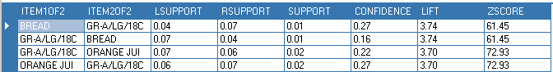

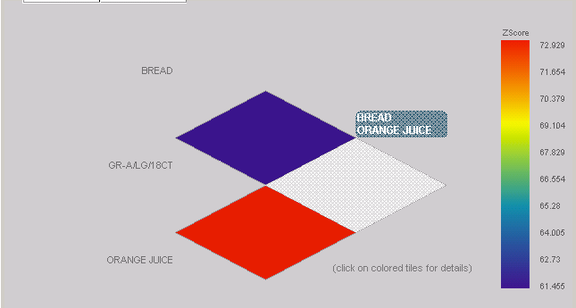

Where Clause:

(store_nbr = 22 OR store_nbr = 24 OR store_nbr = 26) AND (EXTRACT(month FROM transaction_date) = 1 AND EXTRACT(year FROM transaction_date) = 2000 )

Number of transactions = 898739

**Problem 2**:

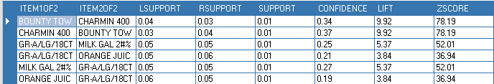

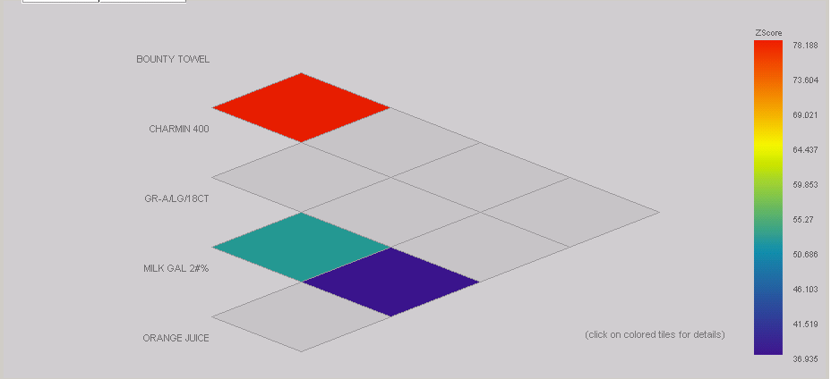

Where Clause:

(store_nbr = 22) AND (EXTRACT(month FROM transaction_date) = 1 AND EXTRACT(year FROM transaction_date) = 2000 )

Number of transactions = 332297

**Problem 3**

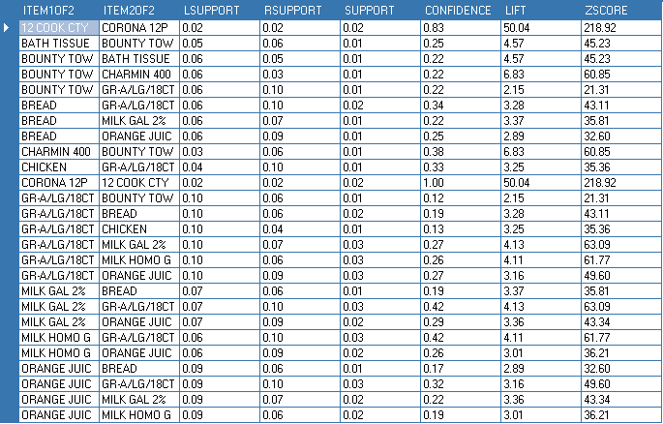

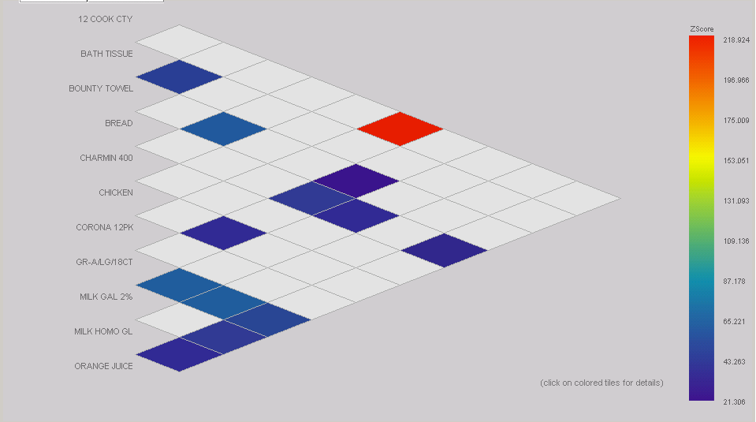

Where Clause:

(store_nbr = 24) AND (EXTRACT(month FROM transaction_date) = 1 AND EXTRACT(year FROM transaction_date) = 2000 )

Number of transactions = 335092

**Problem 4**

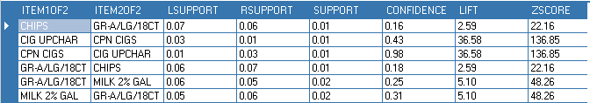

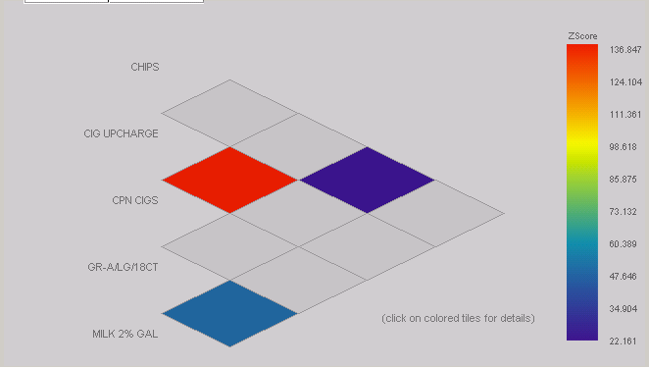

Where Clause:

(store_nbr = 26) AND (EXTRACT(month FROM transaction_date) = 1 AND EXTRACT(year FROM transaction_date) = 2000 )

Number of transactions = 231349